Bryn Loftness

Final Speech Outline

General Purpose: Inform and Entertain Audience on Space

1. Space Facts
   1. Cosmic Address (http://www.jhfestival.org/uploads/2/4/3/7/24374754/cosmos_-_standing_up_in_the_milky_way_script.pdf)
      1. Earth
      2. 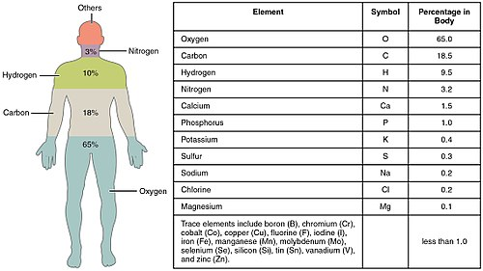Solar System
      3. Milky Way Galaxy
      4. Local group
      5. Virgo supercluster
      6. Observable universe
      7. Multiverse
2. Human Facts
3. Moby – We are all made of stars
   1. Humans are made of space
   2. Diagram Right (<https://en.wikipedia.org/wiki/Composition_of_the_human_body>)
   3. Diagram below (https://en.wikipedia.org/wiki/Abundance_of_the_chemical_elements)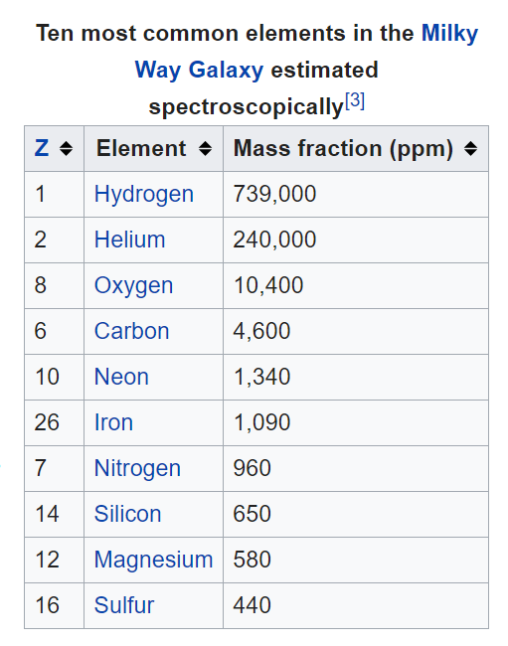
4. Comets
   1. [Comets](https://www.space.com/53-comets-formation-discovery-and-exploration.html) are often known as dirty snowballs, and consist mainly of ice and rock. When a comet's orbit takes it close to the sun, some of the ice in its central nucleus turns into gas that shoots out of the comet's sunlit side, which the solar wind carries outward to form into a long tail.
      1. <https://www.space.com/56-our-solar-system-facts-formation-and-discovery.html>
5. Sun
   1. https://www.space.com/58-the-sun-formation-facts-and-characteristics.html
6. Planets
   1. Mercury
      1. https://www.space.com/36-mercury-the-suns-closest-planetary-neighbor.html
   2. Venus
      1. https://www.space.com/44-venus-second-planet-from-the-sun-brightest-planet-in-solar-system.html
   3. Earth
      1. https://www.space.com/54-earth-history-composition-and-atmosphere.html
   4. Mars
      1. https://www.space.com/47-mars-the-red-planet-fourth-planet-from-the-sun.html
   5. Jupitar
      1. https://www.space.com/7-jupiter-largest-planet-solar-system.html
   6. Saturn
      1. https://www.space.com/48-saturn-the-solar-systems-major-ring-bearer.html
   7. Uranus
      1. https://www.space.com/45-uranus-seventh-planet-in-earths-solar-system-was-first-discovered-planet.html
   8. Neptune
      1. https://www.space.com/41-neptune-the-other-blue-planet-in-our-solar-system.html
   9. Pluto
      1. https://www.space.com/43-pluto-the-ninth-planet-that-was-a-dwarf.html
7. Cosmic Calendar
   1. <http://www.jhfestival.org/uploads/2/4/3/7/24374754/cosmos_-_standing_up_in_the_milky_way_script.pdf>

Ms. Dee,

I know this is a very general outline. My presentation does not reflect the general-ness of this outline. Have no worries about that ☺

Bryn